LA notes/formulas

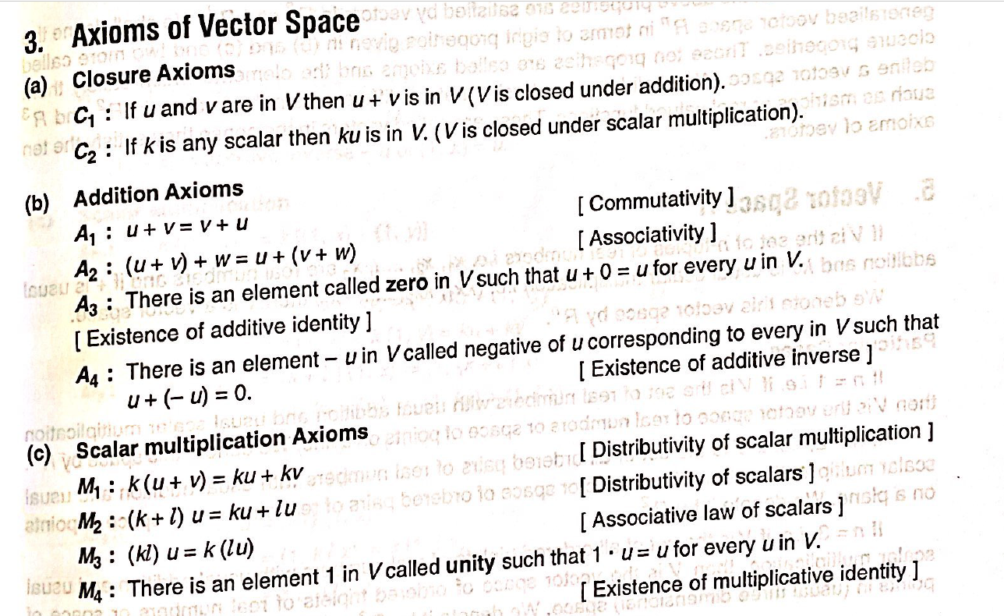

* **Vector space for functions = Function space**
* **R2 = 2 elements in the element of the vector**
* **Set of m x n matrices are vector space under simple addition and multiplication**
* **Space of m x n matrices are denoted by Mmn**

**Subspace:**

**If v1; : : : ; vp are in a vector space V , then Span fv1; : : : ; vpg is a subspace of V .**

* **Line through the origin in R2 is a subspace in R2**
* **W is set of all points in the first quad its NOT A SUBSPACE OF R2.**
* 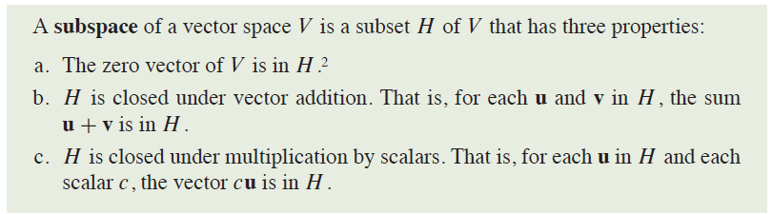
* 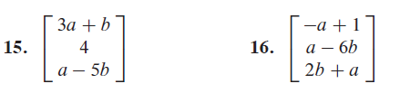
* **These 2 are not vector spaces as the 0 vector doesn’t exist.**

**Span**

* **|A|≠ 0 IT SPANS (Consistent)**
* **Pivot in each row**
* 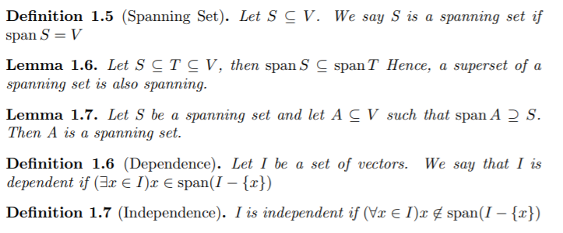

**Linear independence and dependence**

* **If all K =0 then its INDEPENDENT**
* 
* **Pivot in each column**

**Null space**

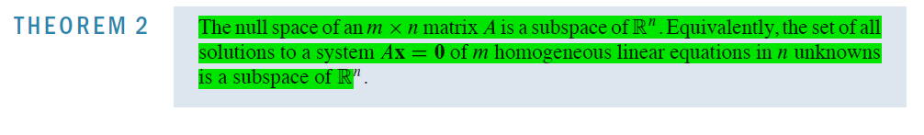

**vectors in X for AX=0**

**Nullity**

* **Rank + Nullity = n**
* **Nullity = n – r**
* **n = no of columns of matrix (no of unknowns)**

**Basis**

* **Should span (non homogen eq)**
* **Linearly independent**
* **Consequently, every basis is the same size**
* **To find basis find the column space of the reduced row echlon form and take the pivot column vectors as the basis.**
* 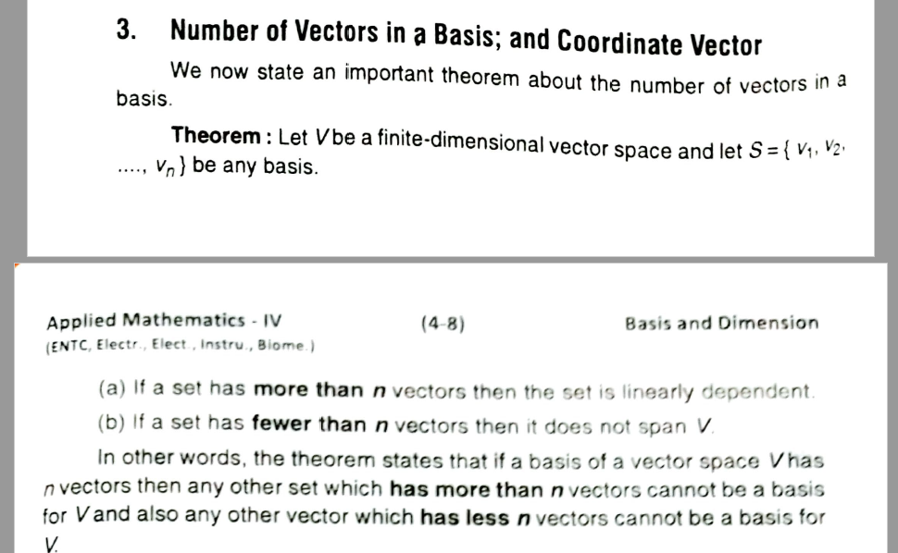
* 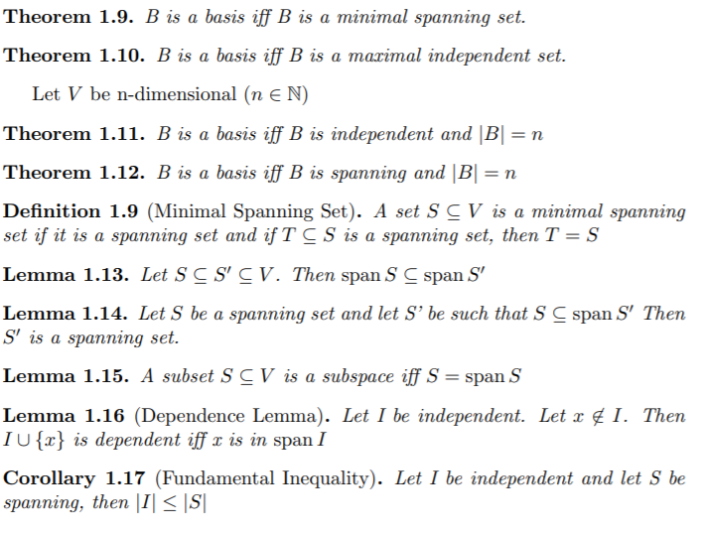

**Dimensions**

• dim({ 0 }) = 0

• dim(Rn) = n

• dim(Pn) = n + 1

• dim(Mmn) = mn

**Orthogonal Projection**

* If u.v = 0, already perpendicular , projection doesn’t exist

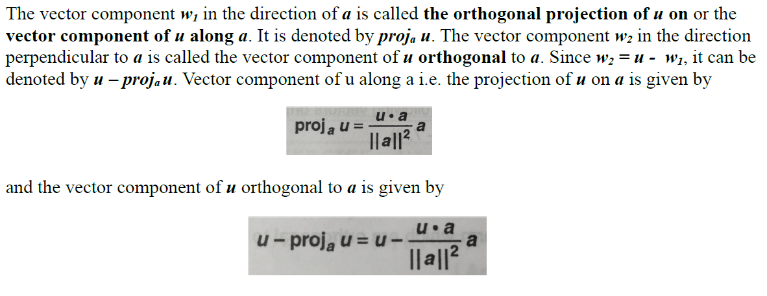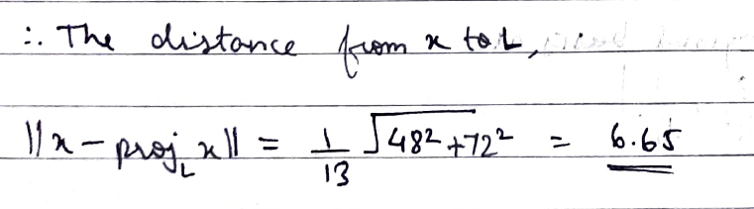

**Row space and column space**

* Find the row echlon form, the non zero rows are the row space.
* In reduced row echlon form , the columns which are non zero – OG columns are the column space
* dimension(rowspace(A)) = Rank(A) = dimension(columnspace(A))
* 
* 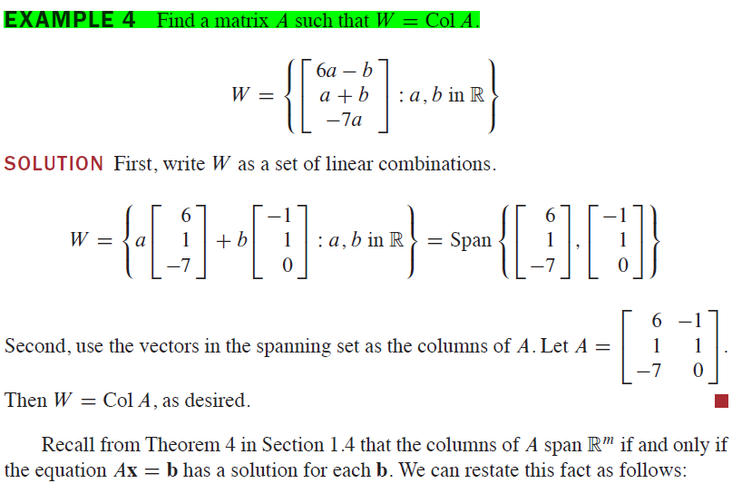

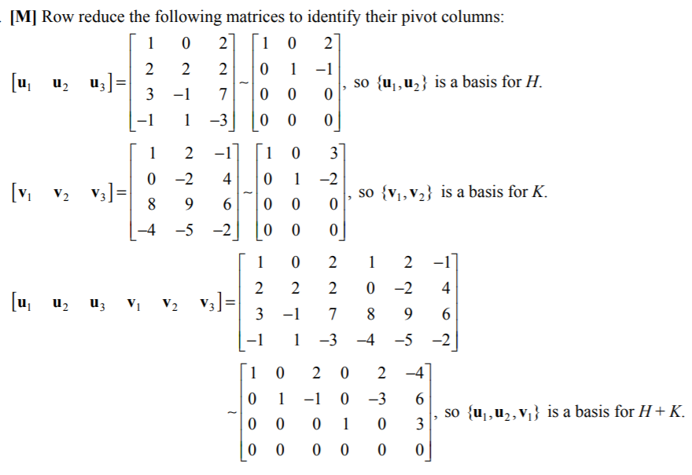

**Least Square method**

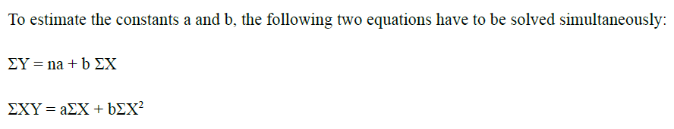

MATRICES:

**Determinant:**

|AB| = |A|*|B|

|KA| = Kn|A|

|An|=(|A|)n

|A-1|=1/|A|

|adjA|=|A|n-1 , |adjadjA|=|A|(n-1) * (n-1)

**Transpose:**

(A+B)′ = A′+B′

(AB)′ = B′A′

(kA)′ = kA′, where k is a constant

|  |  |
| --- | --- |
| Singular Matrix | |A| = 0 |
| Non-Singular Matrix | |A| ≠ 0 |
| Orthogonal Matrix | A AT = In = AT A |
| Idempotent Matrix | A2 = A |
| Involuntary Matrix | A2 = I, A-1 = A |
| Nilpotent Matrix | ∃ p ∈ N such that AP = 0 |

**Inverse of a Matrix**

Below are four properties of inverses.

1. If A is nonsingular, then so is A-1 and  
     
             (A-1) -1  =  A
2. If A and B are nonsingular matrices, then AB is nonsingular and  
     
           (AB)-1  =  B-1A-1  
   -1
3. If A is nonsingular then  
     
             (AT)-1  =  (A-1)T
4. If A and B are matrices with  
     
           AB  =  In  
     
   then A and B are inverses of each other.

Notice that the fourth property implies that if AB  =  I then BA  =  I.

**Transpose conjugate**

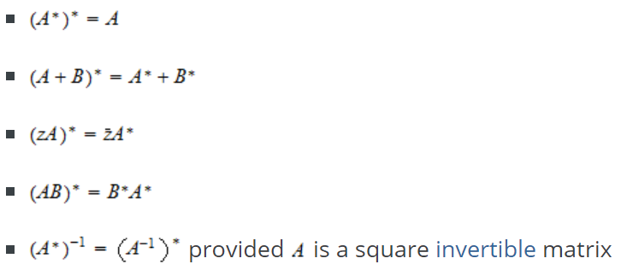

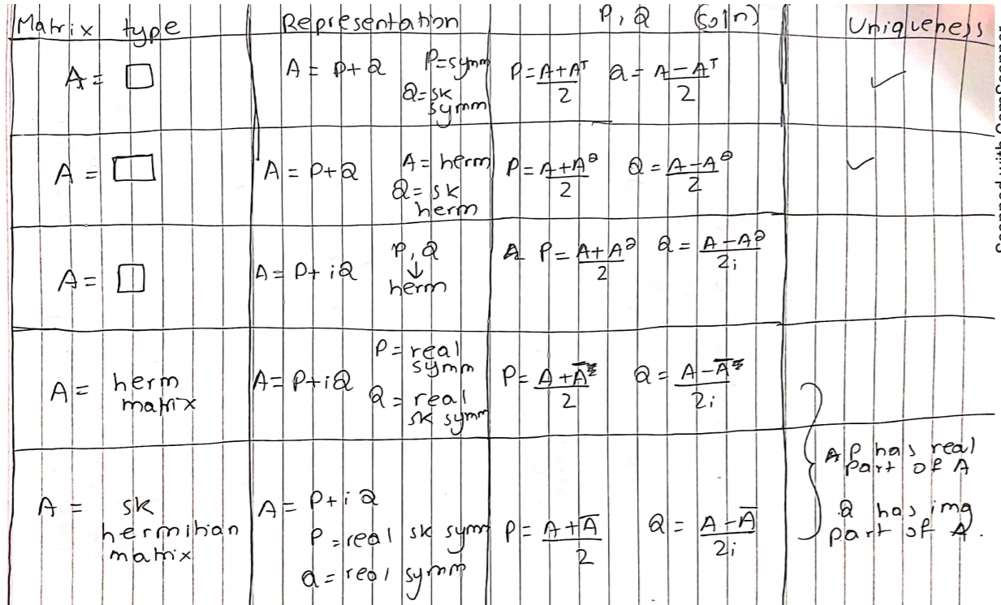

**Hermition**

Aij = conj(Aji)

**Skew Hermition**

Aij = -conj(Aji)

Orthogonal Matrices : ATA = I; AT= A-1

Unitary Matrices: AthetaA=I; Atheta= A-1

RANK:

Rank A = Rank AT

Gauss elimination: row echlon

Gauss Jordon: identity matrix using row trans

Gauss Jacobi: no use of prev values

Gauss seidel: Usage of prev values

Crouts

AX=B

A=LU

LY=B

UX=Y

L= U=

|  |  |  |
| --- | --- | --- |
| a | 0 | 0 |
| b | c | 0 |
| d | e | F |

|  |  |  |
| --- | --- | --- |
| 1 | g | h |
| 0 | 1 | i |
| 0 | 0 | 1 |

LU =

|  |  |  |
| --- | --- | --- |
| a | ag | ah |
| b | Bg+c | Bh+ci |
| d | Dg+e | Dh+ie+f |

KVL

For I and R : negative if current in same direction

For V : Positive if neg side touches first

**EIGEN VECTORS (PROOFS kumbho -26)**

* In 3x3: Sum of roots = trace; Product = |A|
* Char eq = X3-(trace)X2+(Sum of minors of diagonals)X-|A|
* AX= λX
* KX also corresponds to eigen value λ
* Eigen vectors belonging to distinct eigen values are linearly independent
* Eigen values of A-1 are 1/ λ
* Eigen values of adjA = |A|/ λ
* Every sq matrix satisfies its char eqn.

Diagonalization

D=M-1AM

M = each column is the eigen vector

D = Diagonal element are the eigen values

* Sq matrix = Distinct eigen values = diagonalizable
* F(A) = M.F(D).M-1
* eD= ed1 0

1. ed2

* 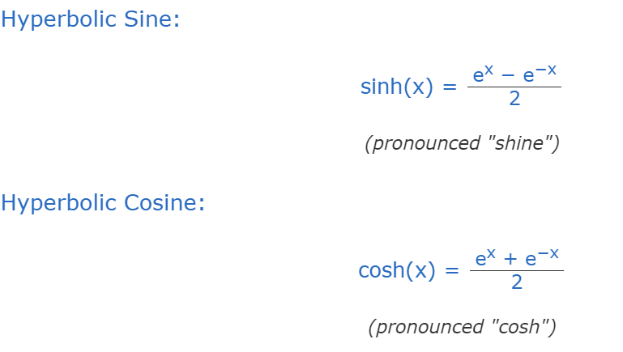
* 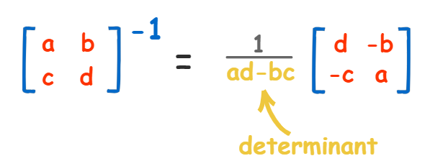

ENCODING DECODING  
No of columns of key = no of rows of Message

KB=X

B=K-1X

A = 1

B = 2

C = 3

D = 4

E = 5

F = 6

G = 7

H = 8

I = 9

J = 10

K = 11

L = 12

M = 13

N = 14

O = 15

P = 16

Q = 17

R = 18

S = 19

T = 20

U = 21

V = 22

W = 23

X = 24

Y = 25

Z = 26